Date | 23/03/2023
To | Sydney Eastern City Planning Panel Chair – Carl Scully  Manager, Place Planning and Environment – Kandace Lindeberg
From | Patrick Santos – Senior Planner
Subject | DA2022/179 – PPSEC-237 – 41 Roberts Rd, Greenacre

This memo has been prepared as a response to an email received from panel coordinator, Suzie Jattan, on Wednesday, 22 March 2023. The email states:

“There is a difference of opinion as to the actual height of the proposal and the control and thus the extent of the variation sought in the cl4.6. If the numbers are wrong in the cl4.6 then, regardless of merits, the cl4.6 might need to be amended. Panel can’t see that the cl4.6 has been amended. In the circumstances, perhaps the applicant should be given the opportunity to amend the cl4.6 (even in a without prejudice form) and we would request council to comment on it by memo before the meeting tomorrow.”

The email from the panel coordinator was relayed to the applicant who provided an amended document Clause 4.6 variation statement. Council is satisfied that the amended Clause 4.6 variation statement, prepared by Keylan Consulting, dated 23 March 2023, ???, is consistent with the Planning report forwarded to the panel for today’s determination.

It is further noted that no adverse environmental impact is envisaged to occur despite the non-compliance and that there is sufficient environmental planning grounds to justify the contravention of the Clause 4.3 Height of Buildings development standard.

The proposed development and the proposed contravention to the development standard is acceptable and that the relevant objectives and provisions of Clause 4.6 are deemed satisfied.

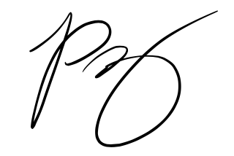
Patrick Santos
SENIOR PLANNER

